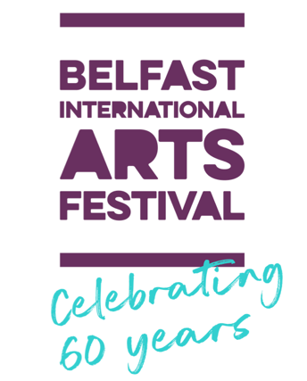
DEVELOPMENT MANAGER
Statement of Suitability

Application Deadline
10am on Tuesday 6 September 2022

PERSONAL DETAILS
Name:
Address
Email
Phone:

PERSON SPECIFICATION
Please use this section to summarise how you meet the Essential Criteria as detailed in the Personnel Specification:
Max 500 Words

Please use this section to summarise how you meet the Desirable Criteria as detailed in the Personnel Specification:
Max 500 Words

What makes you suitable for this role? Include information on your professional fundraising successes.
Max 500 Words

ADDITIONAL INFORMATION
Do you have the right to work in the UK?  Note: the company will require proof of this before an offer of employment can be confirmed – e.g. Birth certificate and/or any other appropriate document required to confirm your right to work in the UK as required by the Asylum and Immigration Act 1996 | Yes | No
Do you require any special arrangements to be made to assist you if called for interview? (if yes, please specify below) | Yes | No

VERIFICATION OF INFORMATION
I certify that all information which I have provided is correct. I understand that any false information given may result in a job offer being withdrawn.

Signature:

Date:

Application Deadline
10am on Tuesday 6 September

Please return this completed Statement of Suitability along with your CV, including details of 2 referees as described in the Job Information, and the separate Monitoring Form to: recruitment@belfastinternationalartsfestival.com

